Crop Recommender System using Machine Learning Techniques for the state of Andhra Pradesh, India

Prof. Raghu B A Rao
Department of Computer Science and Engineering
PES University, Bangalore
Karnataka, India
line 5: raghubarao@pes.edu
Srish Srinivasan
Department of Computer Science and Engineering
PES University, Bangalore
Karnataka, India
line 5: srishwap4@gmail.com
Akash Kumar Rao
Department of Computer Science and Engineering
PES University, Bangalore
Karnataka, India
line 5: akashkrao99@gmail.com
Vishruth P Reddy
Department of Computer Science and Engineering
PES University, Bangalore
Karnataka, India
vishruthpreddy@gmail.com
Ishan Agarwal
Department of Computer Science and Engineering
PES University, Bangalore
Karnataka, India
line 5: ishaanagarwal1605@gmail.com

Abstract—Our project comes under the domain of Precision Agriculture. It helps farmers make informed decisions with regards to the kind of crop they must invest in to get good returns. The aim of this project is to build a predictive model to recommend the most suitable crop to grow based on the various parameters that influence the fertility of the soil with the help of machine learning algorithms. A farmer or a horticulturist toils all day and keeps himself really busy throughout the year by looking after his crops and providing them with the right amount of water and nutrients expecting only one thing in return. And this is good crop yield. But if the farmer or the horticulturist makes a mistake in the very first step by choosing the wrong crop to cultivate, then the all the remaining steps in the process is absolutely useless. So, our main goal in this project is to give the farmer or the horticulturist a sensible start to their cropping season by helping them chose the right crop to grow in their lands so that they are able to obtain a very good yield at the end of the harvest season. The focus will be restricted to a very small part of India and we will be making use of the historic crop yield data for that particular region and try to incorporate machine learning algorithms that can ingest this data in order to build accurate models that could recommend the most ideal crop to be grown when fed with the properties associated with the soil and atmosphere of that region.
Keywords—component, formatting, style, styling, insert (key words)

Introduction
As our project comes under the domain of Precision Agriculture, it is therefore very important to understand what Precision Agriculture means at its core. Precision Agriculture is a system to manage farms that is based on the use of advanced technologies at every step of the agriculture process. It is based on observation, measurement and response to the variability in crops. The aim of precision farming is to develop a decision support system for the management of a farm with the goal being maximization of returns with the efficient and judicious use of resources. In simpler terms, the goal is to increase the harvest through the efficient usage of seeds, fertilizers and pesticides. With the involvement of advanced technology, decisions are made purely based on data thereby reducing the risk of failure to a large extent as decisions are no longer made based on intuition and luck. By making use of resources in an efficient way, we are saving the environment from the rapid depletion of its natural resources.
Precision agriculture originated in the 1980s in the United States of America. Precision agriculture was the most important development of the third wave of modern agricultural revolutions. In the first agricultural revolution that took place between the 1900 to 1930, people saw a large increase in mechanized agriculture. This resulted in each farmer producing food that was more than sufficient to satisfy the hunger of 26 people. Later in the 1960s, people witnessed the second agricultural revolution in the form of Green Revolution which gave birth to genetic modification. At this stage, farmers were able to produce food that was more than sufficient to satisfy the hunger of 156 people. And finally, with rapid technological advancements and its integration in the field of agriculture gave birth to the third agricultural revolution which was widely known as Precision Agriculture. The others synonyms for Precision Agriculture include “Precision Farming”, “Satellite Farming” and “Site Specific Crop Management”. Input recommendation map for fertilizers was the first outcome in this domain and this was based on the grid soil sampling that was done. However, it was in its very early stages and was not practiced much. But with the advent of smartphones, high speed networks and enormous amount of satellite data, precision agriculture has become very popular and has seen a steep growth in the last 5 years.
As we all know, a field has heterogenous zones and with the aid of technology, we can identify these zones and manage their variability. Therefore, it is important to have some knowledge about the technologies being used. The GPS has been one of the most important enabling factors for the practice of precision farming. The farmer’s ability to precisely locate his/her position in the field led to the development of spatial variability maps for variables such as crop yield, nutrient levels, humus content and soil moisture content. Data similar to the ones mentioned in the previous sentence are extracted using sensor arrays mounted on GPS-equipped combine harvesters.
These sensors work in real time thereby collecting a wide spectrum of information ranging from pigment levels to water status, along with multispectral images. This data is used in combination with satellite images through variable rate technology which include seeders, sprayers, etc. in order to achieve optimal distribution of resources. In order to avoid the possibility of an overlap or an underlap during the process of sowing seeds or the application of fertilizers and pesticides, onboard computers and GPS-navigators are used in vehicles. Digital maps and variable rate applications are being used for fields based on variable characteristics and the calculation of fertilizer dosage for every individual zone respectively. With the help of recent technological advancements, real time sensors placed in soil can wirelessly transmit data without the need of human intervention post sensor installment in the soil. For the remote monitoring of fields, drones and satellites have been put to use. Unmanned aerial vehicles are not very expensive and can be controlled by pilots without the need of any prior experience. These drones are equipped with multispectral cameras that can capture multiple images of the field
A lot of sensors have been, predominantly wireless ones have been used in order to numerically capture the influence of field indicators such as moisture, pressure, rainfall, temperature, etc. And finally, with the help of applications that are hosted either as a mobile application or a web application, all the data that has been captured will be analyzed in order to obtain some meaningful insights that can be used to manage farms in an efficient manner.
Coming to the complexity involved in practicing precision farming, it is a little complex because most of the technologies that are being used are new and therefore requires a skilled workforce in order to make good use of this technology. For instance, a person who lacks the required skills will find it difficult to analyze a satellite image or repair an onboard computer. But at the same time, technological solutions that are simple do exist and can be accessed by every farmer. Some of these simple solutions include weather sensors, wireless modems, etc.
The next very important thing to look into is the cost involved in the incorporation precision farming in your farms or agricultural fields. At present, some of the sophisticated equipment and software are quite expensive and therefore the precision farming technologies are mostly seen only in large farm owned by affluent farmers. But it is a well-known fact that with increasing developments in technology, it only becomes more affordable and easier to use. With this natural dynamic, the focus is on enabling easy access to these technologies with very little cost involved.
Stepping into the future, precision agriculture is something that will be unavoidable and it makes absolutely no sense in not making use of it because it is extremely profitable. In one of the blogs by the name onesoil.ai, we learnt that the American farmers are able to save on a large amount of money that they spend on agriculture through the incorporation of precision farming in their fields.
With precision farming up and running, farmers will be able to
1. Make improved decisions
2. Improve the inherent quality of the farm products
3. Enhance marketing of farm products
4. Improve relationships with landlords and local money lenders
So, our focus in this project is to improve the decision making involved in the process of crop selection with the help of machine learning algorithms by taking into account the soil properties and the surrounding atmospheric conditions.

proposed methodology

Dataset
The dataset used in our research work is obtained from an institute called ICRISAT (International Crops Research Institute for the Semi-Arid Tropics) for the state of Andhra Pradesh.
It contains 28 columns and 4800 rows of data. Among these 28 columns, the most important columns are District, Latitude, Longitude, Soil Type, Crop grown previously and various soil components such as N, P, K, Ca, Mg, Cu, pH etc.
Using the details of the latitudes and longitudes, we were able to obtain indices such as NDVI, EVI, ARVI, GCI, NDWI from Google Earth Engine which give more details about the soil regarding fertility and moisture content in the soil.

Approach
After pre-processing the data, we obtained all the necessary columns with cleaned data for analysis. The data was divided based on the districts. For each district, further pre-processing was performed. Using this cleaned data and the indices obtained from Google Earth Engine such as NDVI, NDWI etc, we performed feature selection to obtain the most influential parameters and eliminated the redundant ones. The data was passed through the machine learning models to obtain a list of ideal crops to be grown in the decreasing order of their yield percentage. After identifying the most accurate model and index, we used them for those respective districts for accurate predictions.

Indices
- NDVI
The Normalized Difference Vegetation Index is an index which helps in understanding the greenness of a region. A higher value indicates more greenness (high vegetation areas, healthy plants) and a lower value indicates barren areas (or withering plants). The value of the index lies in between -1 and 1.
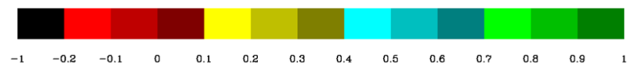
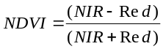,
where NIR = Near Infrared Rays
- EVI
Enhanced Vegetation Index is an optimized vegetation index which works like NDVI providing greenness measure but also provides some correction for noise and atmospheric conditions with better results in areas of high density of vegetation.
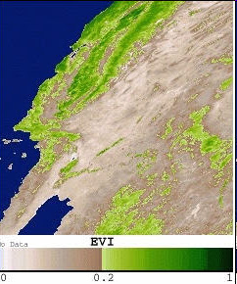
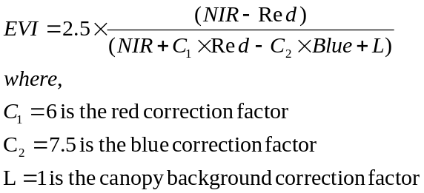
- ARVI
Atmospherically Resistant Vegetation Index is a more refined form of NDVI which amounts for atmospheric correction due to pollutants (aerosol like soot, fog etc). It also provides better results as it takes into account the topology / terrain of the region .This makes it more effective for mountainous regions.
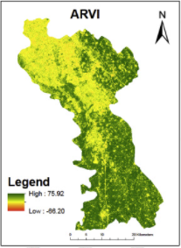
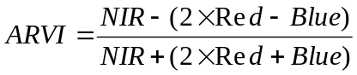
- GCI
Green Chlorophyll Index is the measure of the chlorophyll in leaves. This states the health of the plant / crop and can thus be good for measuring yield. Since it deals directly with the chlorophyll content it can be used in comparing yield before and after using pesticides, accounting for environmental stress on plants etc.
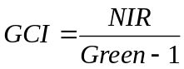
- NDWI
Normalized Difference Water Index is an index which helps to determine the crop condition by accounting for moisture content in plants and crops.This proves helpful for drought prone areas and water stress in vegetation.
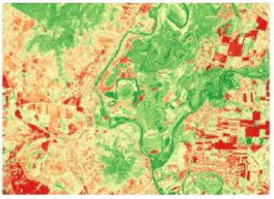
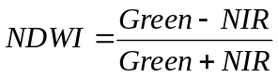

Machine Learning Models
A variety of machine learning models were used to obtain accurate results. The models used for classification were k-Nearest Neighbours, Gradient Boost Classifier, Artificial Neural Network, XG Boost, Random Forest Classifier, Decision Tree Classifier and CatBoost Classifier.

experimental data and results
The data was passed through all the machine learning models. The values obtained from all the models are tabulated below:
(INSERT TABLE/IMAGE HERE)

conclusions
Through the literature survey that we conducted, we learnt about the various machine learning algorithms that have been employed to recommend the most suited crop given the required soil properties of a specific location. On thorough searching, we also came across a relevant dataset for the state of Andhra Pradesh covering 13 districts which also seemed to adhere to the guidelines given to us by our external guide. Therefore, we began to pre-process the dataset and make it suitable enough to perform various analyses for the same.

Authors and Affiliations
The template is designed for, but not limited to, six authors. A minimum of one author is required for all conference articles. Author names should be listed starting from left to right and then moving down to the next line. This is the author sequence that will be used in future citations and by indexing services. Names should not be listed in columns nor group by affiliation. Please keep your affiliations as succinct as possible (for example, do not differentiate among departments of the same organization).

For papers with more than six authors: Add author names horizontally, moving to a third row if needed for more than 8 authors.

For papers with less than six authors: To change the default, adjust the template as follows.

Selection: Highlight all author and affiliation lines.

Change number of columns: Select the Columns icon from the MS Word Standard toolbar and then select the correct number of columns from the selection palette.

Deletion: Delete the author and affiliation lines for the extra authors.

Identify the Headings
Headings, or heads, are organizational devices that guide the reader through your paper. There are two types: component heads and text heads.
Component heads identify the different components of your paper and are not topically subordinate to each other. Examples include Acknowledgments and References and, for these, the correct style to use is “Heading 5”. Use “figure caption” for your Figure captions, and “table head” for your table title. Run-in heads, such as “Abstract”, will require you to apply a style (in this case, italic) in addition to the style provided by the drop down menu to differentiate the head from the text.
Text heads organize the topics on a relational, hierarchical basis. For example, the paper title is the primary text head because all subsequent material relates and elaborates on this one topic. If there are two or more sub-topics, the next level head (uppercase Roman numerals) should be used and, conversely, if there are not at least two sub-topics, then no subheads should be introduced. Styles named “Heading 1”, “Heading 2”, “Heading 3”, and “Heading 4” are prescribed.

Figures and Tables

Positioning Figures and Tables: Place figures and tables at the top and bottom of columns. Avoid placing them in the middle of columns. Large figures and tables may span across both columns. Figure captions should be below the figures; table heads should appear above the tables. Insert figures and tables after they are cited in the text. Use the abbreviation “Fig. 1”, even at the beginning of a sentence.
- Table Type Styles
Table Head | Table Column Head
Table Head | Table column subhead | Subhead | Subhead
copy | More table copyª
- Sample of a Table footnote. (Table footnote)
- Example of a figure caption. (figure caption)
Figure Labels: Use 8 point Times New Roman for Figure labels. Use words rather than symbols or abbreviations when writing Figure axis labels to avoid confusing the reader. As an example, write the quantity “Magnetization”, or “Magnetization, M”, not just “M”. If including units in the label, present them within parentheses. Do not label axes only with units. In the example, write “Magnetization (A/m)” or “Magnetization {A[m(1)]}”, not just “A/m”. Do not label axes with a ratio of quantities and units. For example, write “Temperature (K)”, not “Temperature/K”.

Acknowledgment
The preferred spelling of the word “acknowledgment” in America is without an “e” after the “g”. Avoid the stilted expression “one of us (R. B. G.) thanks ...”. Instead, try “R. B. G. thanks...”. Put sponsor acknowledgments in the unnumbered footnote on the first page.

References
- Keerthan Kumar, T.G., Shubha, C. and Sushma, S.A., Random Forest Algorithm for Soil Fertility Prediction and Grading Using Machine Learning. International Journal of Innovative Technology and Exploring Engineering (IJITEE), 2019.
- Kumar, R., Singh, M.P., Kumar, P. and Singh, J.P., 2015, May. Crop Selection Method to maximize crop yield rate using machine learning technique. In 2015 international conference on smart technologies and management for computing, communication, controls, energy and materials (ICSTM) (pp. 138-145). IEEE. .
- Palanivel, K. and Surianarayanan, C., 2019. An approach for prediction of crop yield using machine learning and big data techniques. International Journal of Computer Engineering and Technology, 10(3), pp.110-118.
- Patil, A., Kokate, S., Patil, P., Panpatil, V. and Sapkal, R., 2020. Crop Prediction using Machine Learning Algorithms. International Journal of Advancements in Engineering & Technology, 1(1), pp.1-8.
- Khaki, S. and Wang, L., 2019. Crop yield prediction using deep neural networks. Frontiers in plant science, 10, p.621.
- Dahikar, S.S. and Rode, S.V., 2014. Agricultural crop yield prediction using artificial neural network approach. International journal of innovative research in electrical, electronics, instrumentation and control engineering, 2(1), pp.683-686.
- Skryjomski, P. and Krawczyk, B., 2017, October. Influence of minority class instance types on SMOTE imbalanced data oversampling. In first international workshop on learning with imbalanced domains: theory and applications (pp. 7-21). PMLR.
- Sharifi, A., 2020. Yield prediction with machine learning algorithms and satellite images. Journal of the Science of Food and Agriculture.
- Sayago, S. and Bocco, M., 2018. Crop yield estimation using satellite images: comparison of linear and non-linear models. AgriScientia, 35(1), pp.1-9
- Sabini, M., Rusak, G. and Ross, B., 2017. Understanding Satellite-Imagery-Based Crop Yield Predictions. Stanford.
- Panda, S.S., Ames, D.P. and Panigrahi, S., 2010. Application of vegetation indices for agricultural crop yield prediction using neural network techniques. Remote Sensing, 2(3), pp.673-696.

